Genomic prediction of swine production traits with multi-omics mixed models
Levi Ayres^{1*}, Henk Bovenhuis¹, Ioanna‑Theoni Vourlaki², Miriam Piles², Maria G. Luigi-Sierra³, Peter Karlskov-Mortensen³, and Mario P. L. Calus¹
¹Animal Breeding and Genomics, Wageningen University & Research, Droevendaalsesteeg 1, P.O. Box 338, 6700AH Wageningen, the Netherlands
²Animal Breeding and Genetics Program, IRTA, Torre Marimón, 08140, Caldes de Montbui, Barcelona, Spain
³Department of Veterinary and Animal Sciences, Faculty of Health and Medical Sciences, University of Copenhagen, Frederiksberg C, Denmark
*Corresponding author
E-mail addresses:
LA: leviayres@icloud.com, https://orcid.org/0009-0002-7744-1894
HB: henk.bovenhuis@wur.nl, https://orcid.org/0000-0002-9074-5334
ITV: ioanna.vourlaki@irta.cat
MP: miriam.piles@irta.es, https://orcid.org/0000-0001-8265-9930
MLS: mgls@sund.ku.dk
PKM: pkm@sund.ku.dk
MPLC: mario.calus@wur.nl, https://orcid.org/0000-0002-3213-704X

Background

Abstract

Background
Current genomic prediction of phenotypes typically relies on single-nucleotide polymorphism (SNP) data from DNA microarrays. Advances in biotechnology now enable large-scale collection of complementary omics data, such as transcriptomics and epigenomics. How much these additional molecular layers improve prediction accuracy, compared to SNP-based models, merits investigation.
We evaluated whether using RNA transcript abundance and DNA methylation levels increased prediction accuracies for four traits in swine: average daily gain (ADG), backfat thickness (BFT), residual feed intake (RFI), and strength score (STR). We obtained transcriptomic (RNA-seq) and epigenomic (reduced representation bisulfite sequencing, RRBS) data from loin muscle biopsies of 443 boars representing the Duroc, Landrace, and Yorkshire breeds. We fitted linear mixed models incorporating genomic, transcriptomic, and epigenomic effects, and evaluated predictive performance as the correlation between observed and predicted phenotypes obtained through cross-validation.
Results
When animals from all breeds were used, the predictive accuracy (measured by the correlation coefficient between predicted values and corrected phenotypes in leave-one-out cross-validation) for ADG ranged from 0.12 with genomic BLUP (GBLUP) to 0.37 with transcriptomic-methylomic BLUP (TMBLUP) and genomic–transcriptomic–methylomic BLUP (GTMBLUP). For BFT, accuracies ranged from 0.18 with methylomic BLUP (MBLUP) to 0.39 with genomic–transcriptomic BLUP (GTBLUP) and GTMBLUP. For RFI, accuracies ranged from 0.19 (pedigree BLUP, GBLUP, MBLUP) to 0.58 (GTBLUP). For STR, accuracies ranged from −0.27 (MBLUP) to 0.11 (TBLUP, TMBLUP, GTBLUP, GTMBLUP). Genomic–methylomic (GMBLUP) and genomic-by-methylomic models (GxMBLUP) displayed intermediate performance.

Conclusions
Adding transcriptomic and methylomic data improved prediction accuracy relative to GBLUP. Overall, TBLUP was the single-omics model that gave the highest accuracies, while MBLUP the lowest. The combined GTMBLUP model, which included all omics, achieved the highest accuracies, although gains over GTBLUP or TMBLUP were modest, when present.

Genetic improvement in livestock populations has relied mostly on mixed model methodology and pedigree-based best linear unbiased prediction (BLUP) over the past five decades [1-4]. By modeling additive genetic effects through pedigree-derived relationship matrices, BLUP selection has helped deliver sustained genetic gains for complex production traits [5-7].
The availability of affordable DNA microarrays enabled genomic selection [8, 9], in which pedigree relationships are replaced or augmented by genomic relationship matrices (GRMs) [10-12]. Genomic best linear unbiased prediction (GBLUP) [13], or its equivalent SNP-BLUP [14] preserves the classical mixed model framework while improving prediction accuracy by capturing realized genetic relationships among individuals [15]. As a result, genomic prediction has become a standard tool in modern livestock breeding programs.
Advances in high-throughput sequencing have enabled the large-scale profiling of additional molecular layers, including the transcriptome and the epigenome, at decreasing cost [16, 17]. These data provide biological information beyond DNA sequence: gene expression reflects the functional state of the genome in cells, whereas DNA methylation contributes to the regulation of gene expression and reflects aspects of developmental history. As such, these omics layers represent additional components of the genotype–phenotype map and may account for variation not captured by SNP markers alone. They are therefore potential candidates for inclusion in genomic prediction models. However, a systematic assessment of their predictive value across species, traits, tissues and omics is still developing.
From a statistical perspective, such omics layers could be incorporated into prediction models by constructing omics-specific relationship matrices and fitting them as additional random effects in a linear mixed model. This would enable the joint modeling of multiple biological data sources while preserving the computational and statistical advantages of classical BLUP approaches.
The objective of this study is to evaluate whether the inclusion of transcriptomic and DNA methylation information improves the accuracy of genomic prediction of phenotypes in commercial pig populations. We compare single- and multi-omics models by assessing predictive performance as the correlation between observed and predicted phenotypes. We also estimate variance components to quantify the relative contribution of each omics layer to phenotypic variation.

Methods

Animals and phenotypes
We obtained data from the DanBred commercial breeding program in Denmark. The dataset comprised 443 male, non-castrated pigs from three pure breeds: Duroc (143), Landrace (148), and Yorkshire (152). These animals were born in the same year and had phenotypes, pedigrees, genotypes, gene expression levels, and DNA methylation information available. The gene expression and DNA methylation levels were obtained from longissimus dorsi muscle biopsies.
We analyzed four production traits: average daily gain (ADG), backfat thickness (BFT), residual feed intake (RFI), and strength score (STR). Phenotypic records were pre-adjusted within breeds for systematic environmental effects of section, sex, parity of dam, and weight at the start of the testing period. The systematic effects were estimated using larger populations maintained by the breeding company as part of their routine genetic evaluation.
Average daily gain (in grams per day) was evaluated in the growth window from 30 to 100 kg of live body weight. Weight and feed intake measurements were taken from electronic feeding stations.
Four backfat thickness measurements (in milimeters) were recorded per boar at approximately 100 kg body weight, and their means were used as the phenotypes. The phenotypes were also adjusted for body weight at scanning.
Residual feed intake was defined as the residual from the linear regression of average feed intake on section, parity of dam, average daily gain, and metabolic body weight. Average feed intake was calculated as the total feed intake (in grams) during trial divided by the number of days in the trial. An individual’s metabolic body weight was defined as
$$MBW=\frac{{{BW}_{t_{2}}}^{1.75}-{{BW}_{t_{1}}}^{1.75}}{1.75\left({BW}_{t_{2}}-{BW}_{t_{1}}\right)}$$
where $BW_{t_{1}}$ and $BW_{t_{2}}$ denote body weight (in kilograms) at the beginning and end of the trial period, respectively.
The strength score was defined as a composite trait derived from the assessment of leg strength, back strength, and overall conformation. Each pig received an integer score from 1 to 14. Strength score records were adjusted body weight.

Information sources
The information sources considered for variance component estimation and prediction were pedigree, genotypes, DNA methylation levels (proportion of methylated reads), and gene expression levels (RNA transcript abundance counts). We used these data to construct relationship matrices describing similarities between animals and fitted them as separate random effects. We applied best linear unbiased prediction (BLUP) to predict phenotypes.
Single-omics models included PBLUP (Pedigree), GBLUP (Genotypes), MBLUP (DNA Methylation), and TBLUP (RNA Transcripts), whereas multi-omics models combined multiple sources of information: GMBLUP (genotype and methylation) and GxMBLUP (genotype, methylation and interaction effect), GTBLUP (genotype and transcripts), and GTMBLUP (genotype, methylation, and transcripts).
We estimated variance components associated with each information source to quantify their contributions to the total phenotypic variance.

Pedigrees
Three breed-specific pedigree files were used to construct the numerator relationship matrices of the PBLUP models. The Duroc, Landrace, and Yorkshire pedigrees contained 8,942, 7,587, and 6,775 animals and spanned up to 44, 53, and 49 generations, respectively.

Genotypes
Animals were genotyped using the GeneSeek Genomic Profiler Porcine 50k SNP array (Neogen Corporation, Lansing, MI, USA). We performed genotype quality control within each breed by excluding single nucleotide polymorphisms (SNPs) with a minor allele frequency less than 1.5%. After filtering, 24,656, 29,556, and 27,854 SNPs remained for the Duroc, Landrace, and Yorkshire breeds, respectively. Because the SNPs retained after quality control differed among breeds, we kept only markers retained in all three breeds for subsequent analyses. This resulted in a common marker panel of 11,822 SNPs.
For the within-breed analyses, we constructed genomic relationship matrices (GRMs) following VanRaden’s first method [13]:
$$G=\frac{ZZ^{⊤}}{2∑p_{i}(1-p_{i})},$$
where Z is the centered genotype matrix and p_{i} is the allele frequency at SNP i.
For the multi-breed analyses, we computed between-breed GRMs as [18]
$$G_{bc}=\frac{Z_{b}Z_{c}^{⊤}}{\sqrt{2\sum_{i}{p_{b_{i}}}(1-p_{b_{i}})} \sqrt{2\sum_{i}{p_{c_{i}}}(1-p_{c_{i}})}},b≠c,$$
where Z_{b} and Z_{c} are centered genotype matrices for breeds b and c, and $p_{b_{i}}$and $p_{c_{i}}$are the corresponding allele frequencies at SNP i.
We then assembled the full multi-breed GRM in block form as [18]
$$G_{\text{all}}=\left[\begin{matrix}G_{DD} & G_{DL} & G_{DY} \\ G_{DL} & G_{LL} & G_{LY} \\ G_{YD} & G_{YL} & G_{YY}\end{matrix}\right].$$
where diagonal blocks correspond to within-breed relationships and off-diagonal blocks correspond to between-breed relationships.

RNA transcripts
At approximately 100 kg live body weight, longissimus dorsi muscle biopsies were collected, snap-frozen in liquid nitrogen and stored at –80°C until processing. Biopsies were used for RNA sequencing (RNA-seq) and reduced representation bisulfite sequencing (RRBS).
Samples with RNA integrity number (RIN) ≥ 7 were retained for polyadenylated mRNA library preparation and sequenced on an Illumina NovaSeq 6000 platform (2 × 150 bp paired-end reads). Reads were quality-controlled, filtered, and aligned to the Sus scrofa reference genome assembly Sscrofa11.1 [19, 20]. Full details can be found in [21]. Counts per million (CPM) values were transformed using a rank-based inverse normal transformation.
We computed the transcriptomic relationship matrix (TRM) as
$$T=\frac{{RR}^{⊤}}{n_{g}},$$where R is the centered and scaled expression matrix and n_{g} is the number of retained genes (14,492).

DNA methylation data
Genome-wide DNA methylation profiles were generated for 452 DanBred male pigs belonging to three breeds using libraries prepared with the Diagenode Premium RRBS v2 kit. Libraries were constructed following MspI digestion, adapter ligation with unique molecular identifiers (UMIs), bisulfite conversion, and PCR amplification, and sequenced on an Illumina NovaSeq 6000 platform to a mean coverage of approximately 40×. For full library preparation and sequencing details, see [21].
Raw sequencing reads were quality-controlled, trimmed, and aligned to the Sus scrofa reference genome (Sscrofa11.1). UMIs were used for deduplication, methylation levels were quantified at CpG dinucleotides, and contiguous CpGs on opposite strands were merged. Methylation levels were expressed as the proportion of methylated reads over total reads at each CpG site, yielding an initial dataset of approximately 4 million CpG sites.
CpG sites were restricted to autosomal regions; reads mapping to unplaced scaffolds, sex chromosomes, and mitochondrial DNA were excluded. We set observations with sequencing depth exceeding the 99.99th percentile of the coverage distribution (783× cutoff) as missing to avoid the influence of abnormally high coverage values likely reflecting technical artefacts. We retained a CpG site for downstream analyses if at least 90% of animals within each breed had a sequencing depth of 5× or greater at that site. We removed individual animals if more than 10% of their CpG observations across the retained sites were missing, resulting in a final dataset of 443 animals (Duroc: 143; Landrace: 148; Yorkshire: 152) and 1,095,304 CpG sites.
For imputation, we replaced remaining missing values within this filtered dataset by the breed-specific median methylation level at that CpG site, as no individual-level information was available for these observations and a complete methylation matrix was required for downstream analyses. We imputed low-coverage observations (1–4 reads) using a Bayesian beta-binomial approach. We modelled the observed number of methylated reads as a binomial random variable with parameters n and p, where n is the read depth (1, 2, 3, or 4) and p is the underlying methylation rate to be estimated. We used a beta distribution as the conjugate prior for p, with its parameters determined by the breed-specific median methylation level at each CpG site. The imputed value was the median of the resulting beta posterior distribution; if the posterior's median was an extremely small numerical value (smaller than 10⁻¹⁰), we rounded it to zero. In total, approximately 2.7% of all CpG-level observations were imputed using this procedure.
We used the methylation levels to construct the methylation relationship matrix as
$$M=\frac{CC^{⊤}}{n_{C}},$$
where C is the matrix of centered and scaled methylation proportions and n_{C} is the number of CpG sites (either 16k or 1M).

We also evaluated a reduced panel of approximately 16,000 CpGs. For each breed, we selected the 50,000 CpGs with the highest sample standard deviation, and defined the final panel as their intersection across breeds (16,074 CpGs). We computed a methylation relationship matrix from this reduced set using the same formulation. All predictions involving models with methylomic effects were calculated with both the full set of 1,095,304 CpGs and with the reduced set of 16,074 CpGs. The variance component estimates of methylation effects that are shown in the bar chart figures (Figures 1 and S5-S13) were obtained using the reduced set of 16,074 CpGs. All results shown here except the tables in SI indicating it used 16k CpGs.

Statistical models
We analyzed phenotypes using single-omics and multi-omics linear mixed models. The general model was:
$$y=μ+\sum_{i}{I_{i}{W_{i}u}_{i}}+e,$$where y is a vector of adjusted phenotypes, μ is a vector of means, 𝕀_{i} is an indicator variable equal to 1 if the i-th omics was included in the model (0 otherwise), W_{i} is an incidence matrix linking animals to random effects, u_{i} is a vector of animal effects for the omics layer i, and e is a vector of residuals. Random effects were assumed to be mutually independent and multivariate normally distributed as
$$u_{i}∼N\left(0,D_{i}σ_{i}^{2}\right),$$
$$e∼N(0,Iσ_{e}^{2})$$where D_{i} denotes the corresponding relationship matrix (pedigree A, genomic G, transcriptomic T, or methylomic M), $σ_{i}^{2}$ is the variance component associated with omics layer i, and $σ_{e}^{2}$ is the error variance.
We estimated the variance components $σ_{g}^{2}$, $σ_{t}^{2}$, $σ_{m}^{2}$, and $σ_{e}^{2}$ to quantify the contribution of each omics layer to phenotypic variation, and the estimates were subsequently used in the mixed model equations to predict the random effects of the different omics layers in each animal. We estimated variances with restricted maximum likelihood (REML) [22, 23]. All prediction accuracies reported in this paper are based on BLUP using REML-derived variance components, as this approach yielded higher prediction accuracies. REML variance component estimation and BLUP predictions were carried out using the R package asreml (22, 23). We note that variance components may have been affected by the fact that they are based on pre-corrected phenotypes [24].
Single-omics models included only one omics source at a time, as indicated by the first letter of the model acronym. For example, the methylomic BLUP (MBLUP) model was defined as
$y=μ+{W_{m}u}_{m}+e$,
with $u_{m}∼N\left(0,Mσ_{m}^{2}\right)$ and $e∼N(0,Iσ_{e}^{2})$. Multi-omics models (TMBLUP, GTBLUP, GMBLUP, GxMBLUP, and GTMBLUP) combined more than one omics layer, again as indicated by the acronym. For example, the GTMBLUP model incorporated genotypic, transcriptomic, and methylomic random effects:
$y=μ+{W_{g}u}_{g}+{W_{t}u}_{t}+{W_{m}u}_{m}+e$,
where $u_{g}∼N\left(0,Gσ_{g}^{2}\right)$, $u_{t}∼N\left(0,Tσ_{t}^{2}\right)$, $u_{m}∼N\left(0,Mσ_{m}^{2}\right)$, and $e∼N\left(0,Iσ_{e}^{2}\right)$.
To account for potential interaction effects between genomic and methylomic effects, we also fitted a G×MBLUP model including a genomic-by-methylomic interaction term:
$$y=μ+{W_{g}u}_{g}+{W_{m}u}_{m}+{W_{gm}u}_{gm}+e,$$
where the interaction effects were assumed to follow $u_{gm}∼N\left(0,\left(G⨀M\right)σ_{gm}^{2}\right)$, with
$G⨀M$ denoting the Hadamard (element-wise) product between the genomic and methylomic relationship matrices [25, 26]. All random effects were assumed to be independent.
The proportion of phenotypic variance due to omics layer i was calculated as
$c_{i}^{2}=\frac{σ_{i}^{2}}{\sum_{j}{σ_{j}^{2}}+σ_{e}^{2}}$,
where the denominator includes all variance components j in the model. For REML, $σ_{i}^{2}$ is the point estimate.

Prediction scenarios
Three cross-validation (CV) schemes were applied: stratified five-fold cross-validation; leave-one-out (LOO) cross-validation; and leave-one-breed-out (LOBO) cross-validation. In (stratified) five-fold cross-validation, the dataset was partitioned into five sets of animals and the model was fitted five times, each time using four sets for training and one set for validation. The partition of the folds is the same as those in Vourlaki et al.[27], which used deep learning to predict phenotypes. A fixed effect for breed was included in models that contained animals from more than one breed.
The five correlation coefficients were summarized by using their median. In leave-one-out (LOO) cross-validation, one animal was removed from the dataset at a time and predicted using a model trained on all remaining animals. In leave-one-breed-out (LOBO) cross-validation, one breed was entirely excluded during training and used as an independent validation set.
Two of the cross-validation schemes here presented are also present in [27], namely LOBO and stratified five-fold cross validation.
For the LOO cross-validation scenario, two cases were evaluated: within breeds and all breeds.
Within-breed models
In these schemes, we analyzed each breed separately to train and test the models. We estimated variance components either from all data or within breeds. For prediction, we applied BLUP and conducted LOO cross-validation within breeds.
All-breeds models
In these scenarios, we jointly analyzed animals from all three breeds (with breed as a fixed effect), to estimate variance components and obtain prediction accuracies. We applied two types of cross-validation: five-fold and LOO cross-validation. Five-fold cross-validation partitions were identical to those in Vourlaki et al. [27]. Prediction accuracy was assessed as the Pearson correlation coefficient between the adjusted phenotypes and their predictions. Once variance components were obtained using all animals, BLUP was applied to the animal or animals in the validation set as if they had no data available, even though their phenotypes were used to obtain the variance components used in the mixed model equations.

Results

Descriptive statistics
All four adjusted traits, average daily gain (g/day), backfat thickness (mm), residual feed intake (g/day), and strength score, had averages close to 0 and exhibited substantial phenotypic variation (Table 1). Histograms of their distributions are presented in Figures S1-S4. Since the phenotypic values were previously adjusted for fixed effects using larger reference populations, the adjusted means in the analyzed subset were close to, but not exactly, zero. Significant positive phenotypic correlations were present between ADG and BFT, ADG and RFI, BFT and RFI, and BFT and STR (Table 2). The correlations among AFG, BFT, and RFI are consistent with previously reported estimates in commercial pig populations [28, 29]. The positive correlation between BFT and STR has not been previously reported and may reflect the limited availability of published estimates on STR.
Table 1 Descriptive statistics for adjusted phenotypes
Trait* | n | Mean | SD | Min. | Max.
Average daily gain (g/day) | 443 | −6.44 | 80.26 | −224.1 | 231.3
Backfat thickness (mm) | 443 | −0.04 | 0.63 | −1.81 | 2.36
Residual feed intake (g/day) | 443 | −3.22 | 131.25 | −889.6 | 525.0
Strength score | 443 | −0.16 | 3.37 | −7.59 | 6.58
*Pre-corrected for systematic effects. n: number of animals; SD: standard deviation; Min.: minimum; Max.: maximum.

Table 2 Correlations among adjusted phenotypes
Trait | ADG | BFT | RFI
BFT | 0.16
RFI | 0.17 | 0.33
STR | −0.04 | 0.21 | 0.08
ADG: average daily gain; BFT: backfat thickness; RFI: residual feed intake; STR: strength score.

Variance component estimates
Figure 1 shows REML-based variance component estimates for the four traits (ADG, BFT, RFI, STR) using animals from all breeds. Each bar represents a model, with coloured segments indicating the proportion of variance explained by genetic (G), transcriptomic (T), methylomic (M), genomic-by-methylomic interaction (G×M), and residual (e) effects. Supplementary Figures S5–S8 show within-breed variance component estimates, with a separate figure for each trait.
Table 3 shows pedigree-based heritability estimates for each trait. REML analyses included only additive genetic effects based on the numerator relationship matrix and used animals from all breeds. STR had the lowest heritability (0.16), whereas BFT and RFI had the highest heritabilities (0.42 and 0.39, respectively). Standard errors were relatively large, indicating uncertainty around the point estimates.
Table 3 Pedigree-based heritability estimates
Trait | h² | SE
ADG | 0.28 | 0.15
BFT | 0.42 | 0.14
RFI | 0.39 | 0.14
STR | 0.16 | 0.14
Variance components estimated using animals from all breeds. h²: heritability; SE: standard error.

Figure 1 shows that GBLUP produced variance component estimates largely similar to those of PBLUP, although a larger difference was observed for STR. Transcriptomic effects (TBLUP) explained a substantial part of the phenotypic variance, with transcriptomic effects explaining the largest proportion of phenotypic variance among the omics in most traits. Methylation effects in MBLUP also explained discernible proportions of phenotypic variance, but to a lesser extent than transcriptomics. In combined models such as GTBLUP, the inclusion of transcriptomic effects appeared to compete with the genetic component, as reflected by a reduced proportion of variance attributed to genotypes compared with GBLUP.
Similar patterns were observed within breeds, where including transcriptomic effects (TBLUP) also explained a substantial part of the phenotypic variance and methylation effects (MBLUP) had a smaller impact. In combined models such as GTBLUP, transcriptomic effects appeared to compete with the genetic component, as indicated by a reduced proportion of variance attributed to genotypes when compared with GBLUP. Some models captured nearly all phenotypic variance (e.g., GTMBLUP for BFT and RFI). Including additional omics components usually increased the total variance explained.
STR stood out as the trait in which residual variance predominated across all models, with low heritability and modest contributions from the omics components. In contrast, RFI had smaller residual variance proportions, with transcriptomic effects explaining a large share of the total variance.
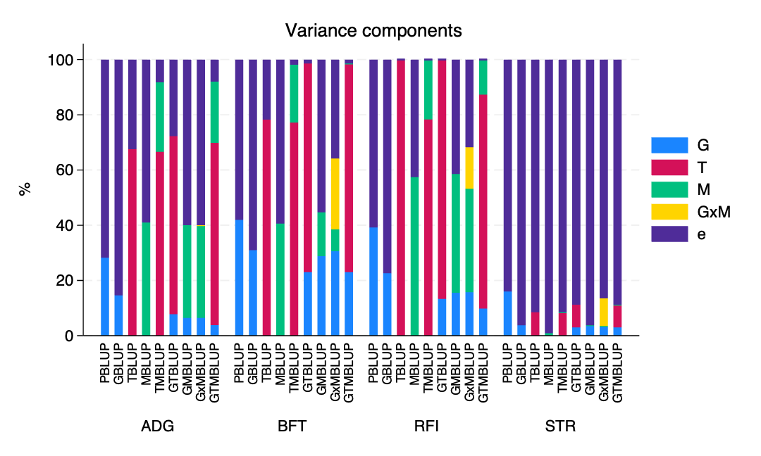Fig. 1 Variance components as proportions of total phenotypic variance for four production traits in pigs. Stacked bars represent the proportion of phenotypic variance attributed to each component within a given model. G: genomic; T: transcriptomic; M: methylomic; G×M: genomic×methylomic interaction; e: residual. ADG: average daily gain; BFT: backfat thickness; RFI: residual feed intake; STR: strength score.

Prediction accuracy in the ‘All breeds’ scenario
In the all-breeds scenario, prediction accuracies were higher, consistent with the larger number of animals in the training data set. Accuracy differed across traits. Smaller within-breed sample sizes affect breed-specific estimates, and the all-breeds scenario provides a more robust summary of overall patterns.
Table 4 and Figure 2 show LOO cross-validation prediction accuracies in the ‘All breeds’ scenario. Models including transcriptomic information (TBLUP, TMBLUP, GTBLUP, and GTMBLUP) consistently achieved the highest prediction accuracies across traits. Prediction accuracies were highest for RFI and lowest for STR.
In all traits, models including transcriptomic information outperformed genomic and methylation-based models. Methylation-only models (MBLUP) showed moderate prediction accuracies for ADG, BFT, and RFI, but performed poorly for STR.
Combining genomic information with transcriptomics (GTBLUP) led to small increases in prediction accuracy for some traits, particularly BFT and RFI. In contrast, adding methylation to transcriptomic models (TMBLUP vs. TBLUP, and GTMBLUP vs. GTBLUP) resulted in little or no change in prediction accuracy. As a result, the three-omics model (GTMBLUP) performed similarly to the best two-omics models.

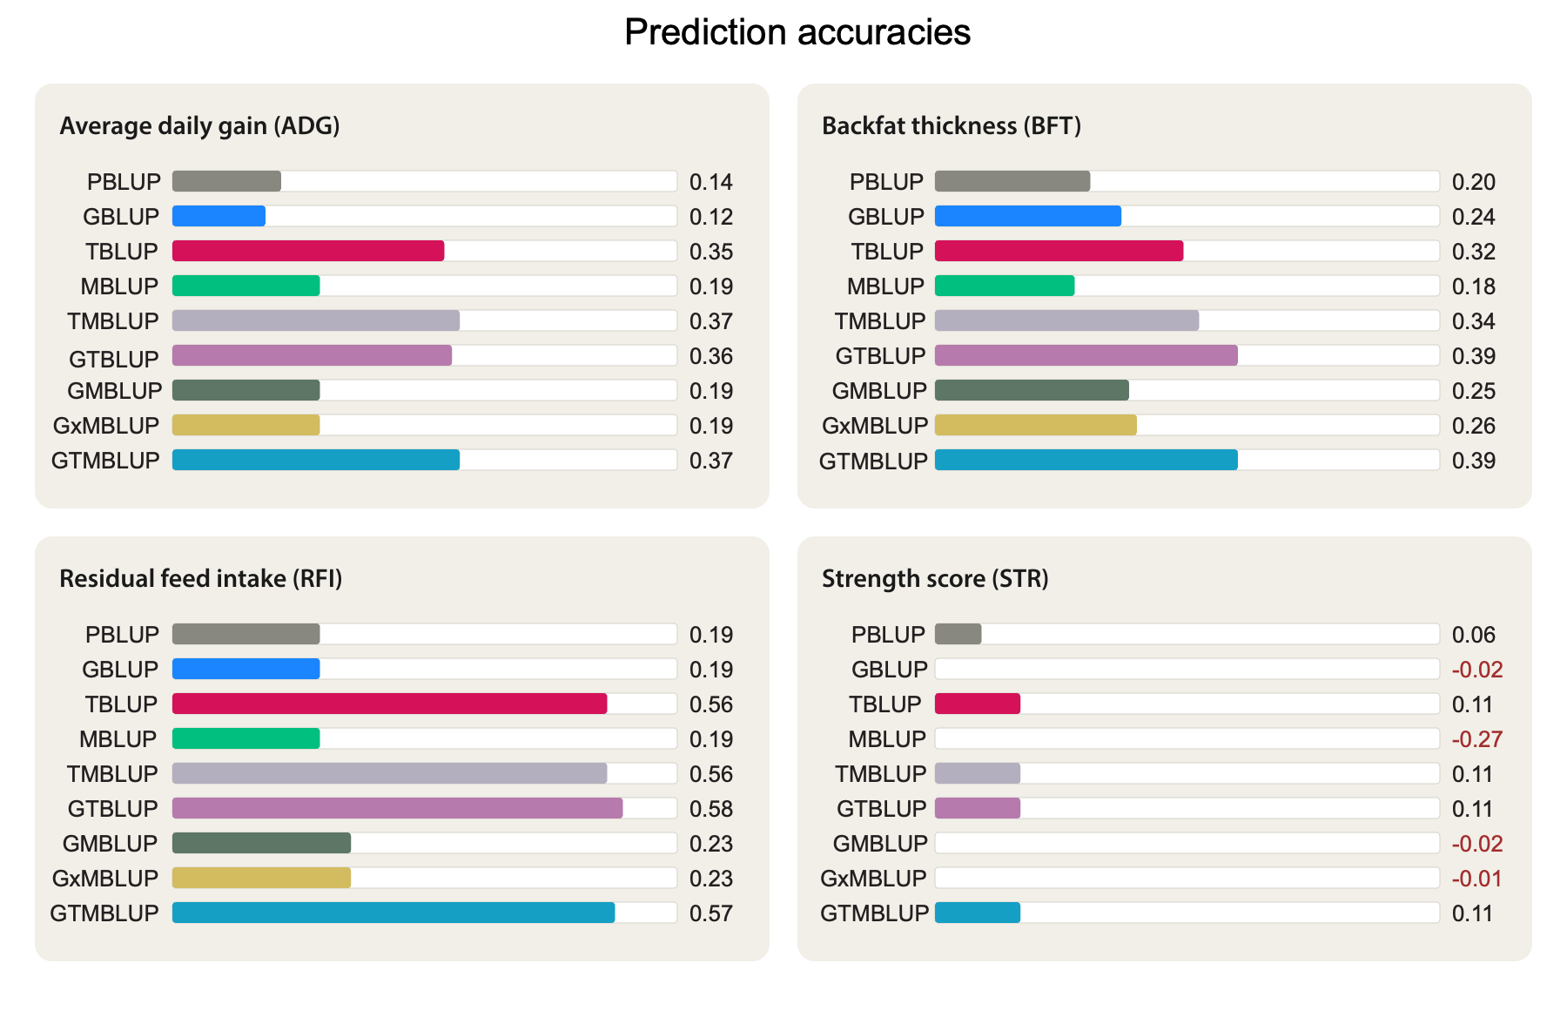Fig. 2. Prediction accuracies of the different model in leave-one-out cross-validation using all breeds.
Table 4 Prediction accuracies in leave-one-out cross-validation
Model | ADG | BFT | RFI | STR
PBLUP | 0.14 | 0.20 | 0.19 | 0.06
GBLUP | 0.12 | 0.24 | 0.19 | −0.02
TBLUP | 0.35 | 0.32 | 0.56 | 0.11
MBLUP | 0.19 | 0.18 | 0.19 | −0.27
TMBLUP | 0.37 | 0.34 | 0.56 | 0.11
GTBLUP | 0.36 | 0.39 | 0.58 | 0.11
GMBLUP | 0.19 | 0.25 | 0.23 | −0.02
GxMBLUP | 0.19 | 0.26 | 0.23 | −0.01
GTMBLUP | 0.37 | 0.39 | 0.57 | 0.11
ADG: average daily gain; BFT: backfat thickness; RFI: residual feed intake; STR: strength score.

Five-fold cross-validation
The results from the stratified five-fold cross-validation using all breeds are given in Table S1. Overall, prediction accuracies were similar to those observed in the leave-one-out cross validation scheme and followed the same pattern, with transcriptomic models outperforming genomic and methylomic ones and combined omics models sometimes achieving the highest accuracies. The main difference was in the accuracies for STR, which were slightly higher than those from the leave-one-out cross-validation scheme, with no negative values being present. Accuracies for the GTMBLUP model were 0.39, 0.39, 0.59, and 0.17 for ADG, BFT, RFI, and STR, respectively.

Prediction accuracies within breeds
Within-breed prediction accuracies are shown in Table S2. The table shows the predictions that were computed using REML variance components fixed at values estimated using all animals from all breeds (these are the same components used for the BLUPs in the ‘All breeds’ scenario); we also calculated accuracies using REML variance components estimated within breeds but the results were similar. In general, prediction accuracies within breeds had a similar pattern to those from the combined-breed analyses but were, on average, lower than those of the other scenarios. One exception were the ADG accuracies of the Landrace pigs, which were slightly higher than those from the multi-breed analyses.

Prediction accuracies in the LOBO scenario
Prediction accuracies for the LOBO (leave-one-breed-out) scenario using 16 thousand CpGs are shown in Table S4. Accuracies for the models using the methylation relationship matrix derived from 1 million CpG are provided in Table S8 and were in general similar to those obtained with the reduced 16k CpG panel.
Prediction accuracies from leave-one-breed-out cross-validation were breed and trait dependent and were generally lower than those observed in the within-breed LOO cross-validations. Genomic models showed limited accuracy, while transcriptomic and multi-omics models showed higher accuracies. The highest accuracies across all scenarios were attained by the TBLUP and GTBLUP models for RFI in LOBO.

Single-omics vs. multi-omics
Prediction accuracy differed across single-omics models, with TBLUP outperforming both GBLUP and MBLUP across traits. When extending models by adding a second omics layer, the effect depended on the combination considered. Adding genomic information to transcriptomic models (GTBLUP) resulted in small changes relative to TBLUP, with slight increases for some traits and little difference for others. Adding methylation to genomic models (GMBLUP) resulted in small changes in prediction accuracy relative to GBLUP, with increases observed in some cases.
Extending models from two to three omics layers (GTMBLUP) resulted in only minor changes relative to GTBLUP, with both increases and decreases observed depending on the trait. A similar pattern was observed when adding interaction effects to GMBLUP (GxMBLUP).

Number of CpG sites evaluated in the model
For each model including methylomic effects, we evaluated two versions using either 16k or 1M CpG sites (Tables S5-S9). Overall, the 16k models showed more stable performance across traits, model specifications, and cross-validation schemes, and in some instances outperformed the 1M versions. For GTMBLUP, prediction accuracies were essentially identical between the 16k and 1M implementations.

Summary of main findings
Transcriptomic effects explained the largest proportion of phenotypic variance and delivered the highest prediction accuracies across traits, breeds, and cross-validation schemes. Although methylomic variance components were often larger than genomic components, this did not translate into superior predictive performance. TBLUP was the best-performing single-omic model, and combining genomic and transcriptomic effects yielded the highest overall accuracies. This pattern is also reflected in the aggregate results (Table S10), where transcriptomic and combined models showed the highest average prediction accuracies, while the inclusion of methylation resulted in small changes in accuracy.

Discussion
To our knowledge, this is the first study in animal breeding to jointly use genomic, epigenomic, and transcriptomic profiles measured on the same individuals to predict complex traits. In this paper, we employed linear mixed models to do prediction. In the companion paper by Vourlaki et al. [30], deep learning methods were applied to the same dataset.
Studies incorporating DNA methylation directly into genomic prediction have have been conducted in plant species, including Arabidopsis thaliana [31-33] and barley (Hordeum vulgare) [34, 35], and on humans, where methylation data have been used to predict traits such as biological age, smoking, alcohol intake , blood cholesterol, body mass index, height, clinical depression and rheumatoid arthritis [36-41]. By using cytosine methylation profiles from RRBS, our study extends this line of inquiry to livestock, where multi-omics prediction is beginning to be explored.
Another line of inquiry are studies that have utilized epigenomic and transcriptomic data to assign weights to SNPs [42, 43]. However, these omics measurements are typically derived from animals outside the prediction dataset, making their integration indirect.

Transcriptomic vs. epigenomic contributions
Among the omics layers we examined, transcriptomic information explained a considerable proportion of the phenotypic variance and yielded the greatest improvements in predictive ability over SNP-based genomic prediction, a finding consistent with recent reports [44-49]. DNA methylation, on the other hand, explained a smaller proportion of the phenotypic variance and provided modest gains in accuracy; it generally underperformed as a standalone predictor but occasionally contributed incremental improvements when combined with other omics layers. This difference may reflect the closer functional proximity of gene expression to phenotypic outcomes: transcriptomic profiles capture variation that is already downstream of both genetic and epigenetic regulation, and may therefore carry more trait-relevant signal. Nevertheless, given that methylation is associated with the regulation of gene expression, its impact on phenotypic variance is expected to be mediated, at least in part, through gene expression. Based on this, we may expect a similar contribution of the methylome and transcriptome to phenotypic variance. In this respect, the observed differences in variance explained may in part be explained by the nature of the two data sources. Transcriptomic data is naturally limited to variation in gene activity and is focused on the functional genome, while the methylation profiles used here were designed to capture genome-wide variation rather than focusing on functional regions (e.g., promoters or enhancers). This could suggest that modelling the impact of epigenetic effects on phenotypic variance may be improved by focusing on regions with defined functionality.

Effect of the number of CpG sites

Reducing the number of CpG sites from approximately 1 million to approximately 16 thousand had model-and trait-dependent effects on predictive performance. In methylomic-only models (MBLUP), the reduced CpG set consistently gave higher prediction accuracies across traits, breeds, and cross-validation schemes (Tables S4–S8), with the largest differences observed for STR, the trait with the lowest heritability. Models with transcriptomic information (TMBLUP and GTMBLUP) showed almost identical results for both CpG sets, while models combining genomic and methylation information (GMBLUP and GxMBLUP) showed often small and inconsistent differences. The high correlation between off-diagonal elements of the methylation relationship matrices from the full and reduced CpG sets (r = 0.91) indicates that the smaller set captured most of the similarity among animals. <Note from Levi to himself: MAF filtering comparable to selecting most variable sites?>
[Insert figure Plot or histogram Wait for Marias opinion Perhaps mention it perhaps results from contamination]

These results support the feasibility of using reduced-density methylation microarrays for prediction, as recently developed in the RUMIGEN project [50]. In addition to selecting the most variable CpG sites for the chip, specific regions or functional categories could also be considered. A similar trend is seen in genomic prediction using whole-genome sequence data, where increasing marker density beyond a certain point often provides little improvement in accuracy [CITATION needed], largely due to redundancy and linkage disequilibrium between markers. In methylation data, this redundancy appears to be lower, so correlations between reduced and full datasets are correspondingly weaker.

Modelling
The models applied in this study are based on the standard BLUP framework [51-54], with additional molecular sources of variation (omics) fitted as independent random effects. For example, in GTMBLUP, genomic, transcriptomic, and methylomic effects were included as separate random effects, whose sum determines the predicted phenotype. The covariance structures for the genomic, transcriptomic, and methylomic components covariance structures were all defined using relationship matrices proportional to $XX^{⊤}$, where X represents the standardized omics matrix. This framework preserves the covariance structure of established quantitative genetic models in animal breeding and enables evaluation of the relative contributions of omics-derived relationship matrices to predictive performance.
However, one limitation should be noted. The model assumes independence between genomic, methylomic, and transcriptomic effects, despite known biological dependencies among these layers. Genetic variation can influence both methylation and gene expression, and methylation may regulate transcription; associations among SNPs, CpG sites, and transcripts have been reported [55], indicating that this assumption is a simplification.
More flexible approaches have been proposed to relax these model assumptions. For example, CORE-GREML [56] allows covariance between random effects, while multi-omics BLUP extensions, such as GTCBLUP [44, 46], aim to account for shared or redundant information between predictors. Another alternative is GOBLUP [57-61], which adopts a hierarchical framework in which one model relates the phenotype to genomic and omics predictors, while a second model relates omics predictors to genomic information. From a breeding perspective, interest typically lies in predicting breeding values rather than phenotypes. One approach would be to rely only on genomic effects from models such as GBLUP, GTBLUP, GMBLUP, GxMBLUP, or GTMBLUP. However, this raises concerns about confounding, as non-genetic omics effects may be partially absorbed into estimated genetic values.

Within-breed vs. across-breed prediction
Across-breed (LOBO) prediction accuracies were not consistently lower than those obtained from the within-breed scenarios, despite having a larger (double) training population in the across-breed scenario. Results were highly breed-, trait-, and model-dependent. If the sample sizes were the same, though, we would have expected higher accuracies in the within-breeds scenario. In the LOBO scheme, the Duroc breed had the lowest mean accuracy considering all models and trait combinations. This is somewhat expected as Landrace and Yorkshire are genetically more similar than the Duroc breed.

Limitations and further work
The number of animals within individual breeds remains moderate relative to the complexity of multi-omics models, which may contribute to variability in within-breed prediction and affect the precision of breed-specific estimates. Expanding sample size would allow more robust comparisons between models and clearer assessment of the contribution of each omics layer.
In addition, the modelling framework assumes independence between omics layers and uses estimated variance components as fixed inputs for prediction, which may not fully capture biological dependencies or account for uncertainty in parameter estimation. More flexible approaches that allow dependencies between molecular layers could be explored.
The omics layers we considered were genomics, transcriptomics, and epigenomics (DNA methylation). Additional molecular layers, such as chromatin accessibility, histone modifications, proteomics, or metabolomics, may provide complementary information and warrant further investigation.
Finally, transcriptomic and methylomic data were obtained from longissimus dorsi muscle. Given the tissue-specific nature of gene expression and epigenetic regulation, the predictive value of these molecular layers may depend on how closely this tissue reflects the biology of each trait, and evaluation of additional tissues may help assess the generality of the results.

Conclusions
Transcriptomic and methylomic components captured additional variance beyond pedigree and genomic effects. Models integrating multiple omics layers generally achieved the highest prediction accuracies in this study, with transcriptomic information consistently providing the largest contribution to predictive performance. Thus, the inclusion of gene expression data clearly improved prediction accuracy of the swine production traits compared with models based solely on genomic markers. In contrast, DNA methylation showed more modest and trait-dependent effects, contributing limited additional improvement in most cases but occasionally enhancing prediction in specific breed–trait combinations.
The stronger predictive value of transcriptomic information is consistent with the biological role of gene expression as a downstream molecular state that reflects the combined influence of genetic and regulatory processes. As such, transcriptomic profiles may capture variation that is more directly associated with phenotypic differences than upstream regulatory signals such as DNA methylation. At the same time, the benefits of incorporating additional molecular layers were not uniform, and gains in prediction accuracy depended on the trait, breed, and modeling context considered.
Our results show that integrating multiple sources of molecular information can improve phenotype prediction in livestock populations, but they also indicate that the inclusion of additional omics does not automatically translate into substantial gains in accuracy.

Abbreviations
BLUP: best linear unbiased prediction; PBLUP: Pedigree BLUP; GBLUP: Genomic BLUP; TBLUP: Transcriptomic BLUP; MBLUP: Methylomic BLUP; TMBLUP: Transcriptomic-Methylomic BLUP; GTBLUP: Genomic-Transcriptomic BLUP; GMBLUP: Genomic-Methylomic BLUP; GxMBLUP: Genomic×Methylomic BLUP; GTMBLUP: Genomic-Transcriptomic-Methylomic BLUP. REML: restricted maximum likelihood. GOBLUP: Genomics Omics BLUP; GRM: genomic relationship matrix. DD: Duroc; LL: Landrace; YY: Yorkshire. CpG: cytosine-phosphate-guanine; 16k: 16,074 CpG sites; 1M: 1,058,533 CpG sites. CPM: counts per million; DNA: deoxyribonucleic acid; PCR: polymerase chain reaction; RNA: ribonucleic acid; mRNA: messenger RNA; RNA-seq: RNA sequencing; RIN: RNA integrity number; RRBS: reduced representation bisulfite sequencing; SNP: single-nucleotide polymorphism; UMI: unique molecular identifier. ADG: average daily gain; BFT: adjusted backfat thickness in milimeters; BW: body weight in kilograms; MBW: metabolic body weight in kilograms; RFI: residual feed intake in grams per day; STR: strength score; g/day: grams per day; mm: milimeters. h²: estimated heritability; Min.: minimum; Max.: maximum; SD: standard deviation; SE: standard error; n: number of animals; r: Pearson’s correlation coefficient. LOBO: leave-one-breed-out; LOO: leave-one-out. RUMIGEN: Towards improvement of RUMInant breeding through GENomic and epigenomic approaches; GEroNIMO: Genome and Epigenome eNabled breedIng in MOnogastrics.
Acknowledgements
We thank LF, Breeding & Genetics, Danish Agriculture & Food Council F.m.b.A., for providing the data used in this study.

Funding
This research received funding from the European Union’s Horizon 2020 programme through grant agreement No. 101000236 (GEroNIMO project).

Supplementary Information

Histograms of adjusted phenotypes
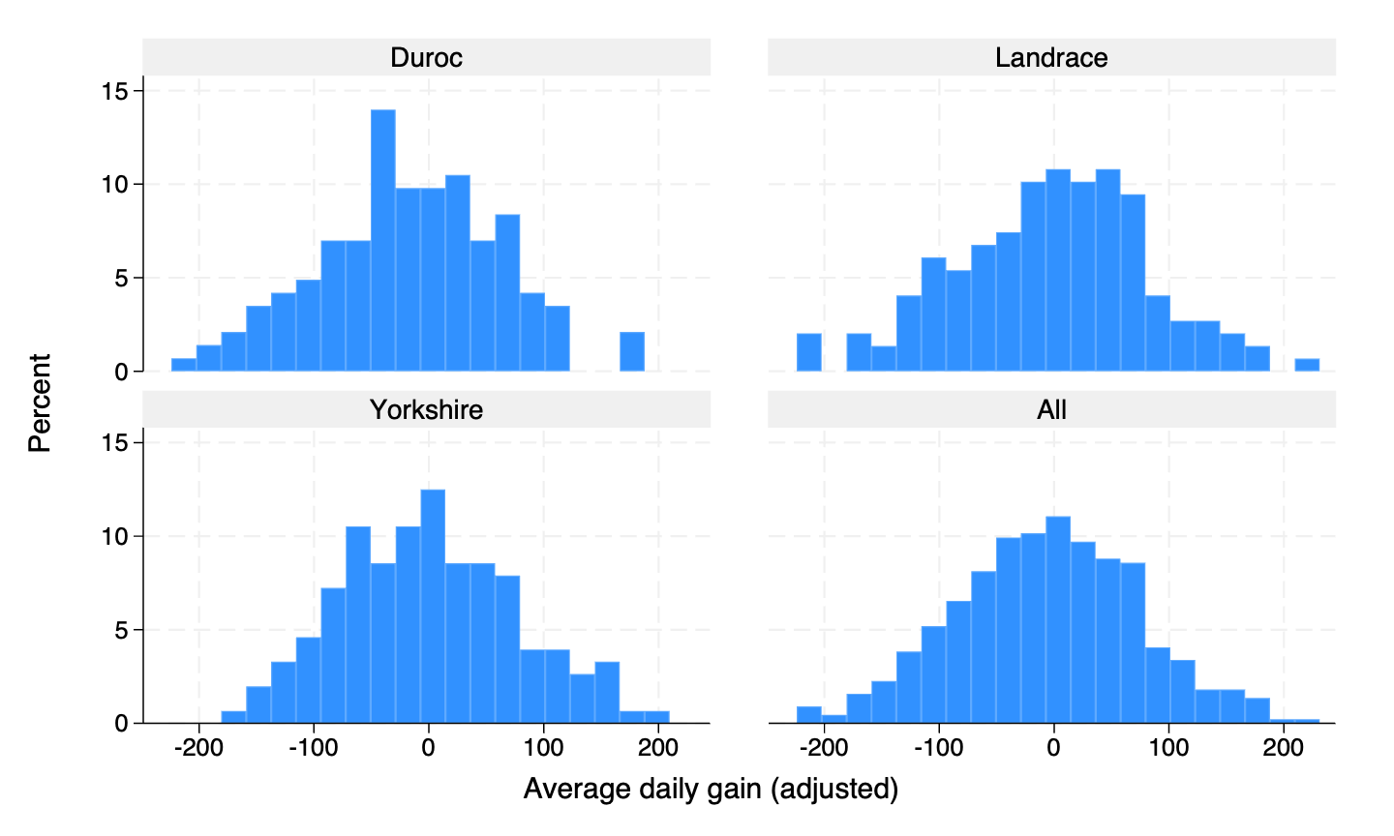
Fig. S1 Histograms of distributions of adjusted average daily gain, per breed and combined.
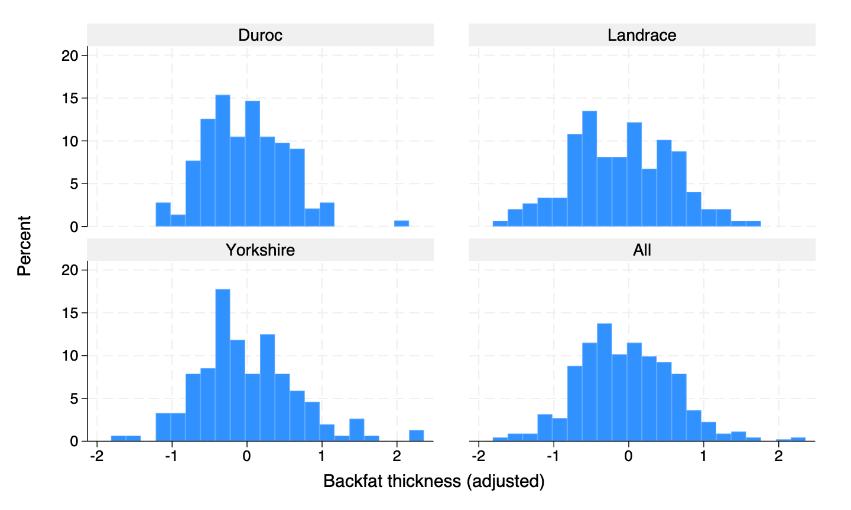
Fig. S2 Histograms of distributions of adjusted backfat thickness, per breed and combined.

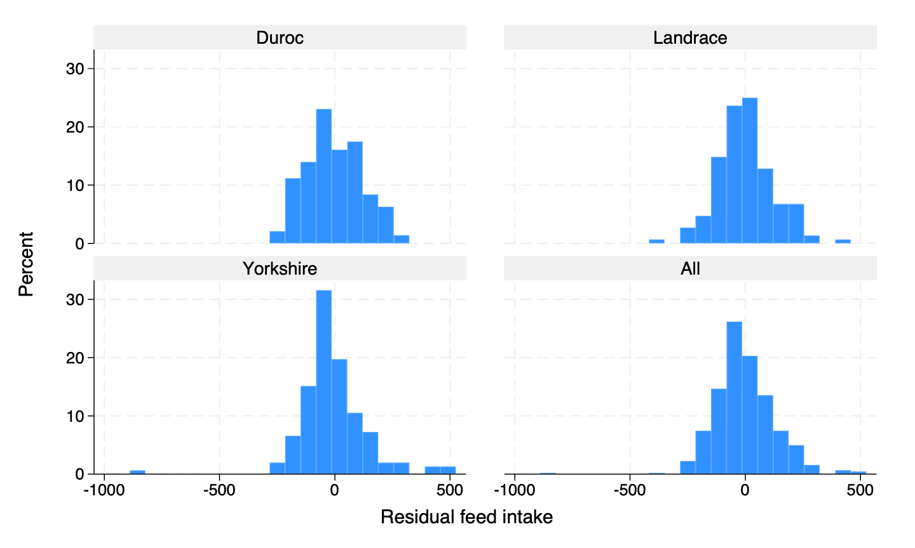
Fig. S3 Histograms of distributions of residual feed intake, per breed and combined.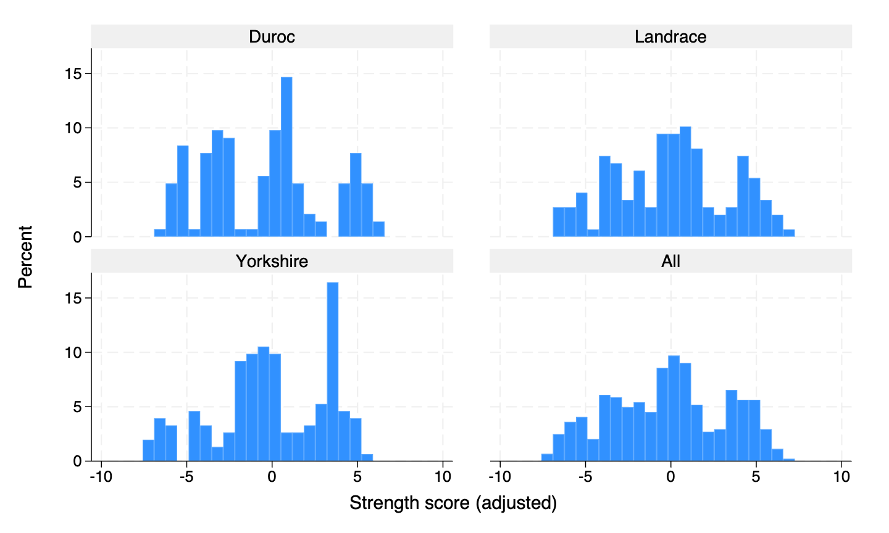
Fig. S4 Histograms of distributions of the adjusted trait strength score, per breed and combined.

Tables of genomic prediction accuracies

Model | ADG | BFT | RFI | STR
PBLUP | 0.18 | 0.18 | 0.21 | 0.11
GBLUP | 0.20 | 0.24 | 0.18 | 0.00
TBLUP | 0.39 | 0.33 | 0.58 | 0.17
MBLUP | 0.20 | 0.19 | 0.14 | 0.05
TMBLUP | 0.38 | 0.37 | 0.58 | 0.17
GTBLUP | 0.36 | 0.39 | 0.60 | 0.17
GMBLUP | 0.16 | 0.26 | 0.19 | 0.06
GxMBLUP | 0.16 | 0.26 | 0.20 | 0.08
GTMBLUP | 0.39 | 0.39 | 0.59 | 0.17
Table S1 Median prediction accuracies across folds in five-fold cross-validation using all breeds

Table S2 Prediction accuracies from leave-one-out cross-validation (within breeds)*
Model | Duroc |  |  |  |  | Landrace |  |  |  |  | Yorkshire
 | ADG | BFT | RFI | STR |  | ADG | BFT | RFI | STR |  | ADG | BFT | RFI | STR
PBLUP | 0.07 | 0.01 | 0.24 | 0.05 |  | 0.19 | 0.36 | 0.08 | −0.12 |  | 0.01 | −0.01 | 0.19 | 0.06
GBLUP | 0.07 | 0.06 | 0.14 | −0.14 |  | 0.21 | 0.35 | 0.13 | −0.37 |  | -0.10 | 0.11 | 0.25 | −0.12
TBLUP | 0.29 | 0.29 | 0.45 | 0.18 |  | 0.46 | 0.33 | 0.56 | −0.07 |  | 0.36 | 0.13 | 0.45 | −0.07
MBLUP | 0.14 | 0.03 | 0.29 | −0.37 |  | 0.21 | 0.34 | 0.15 | −0.80 |  | −0.05 | 0.03 | 0.14 | −0.84
TMBLUP | 0.33 | 0.25 | 0.47 | 0.18 |  | 0.48 | 0.34 | 0.54 | −0.07 |  | 0.34 | 0.13 | 0.49 | −0.07
GTBLUP | 0.31 | 0.30 | 0.46 | 0.19 |  | 0.47 | 0.39 | 0.56 | −0.09 |  | 0.34 | 0.18 | 0.49 | −0.04
GMBLUP | 0.13 | 0.07 | 0.26 | −0.14 |  | 0.22 | 0.36 | 0.17 | −0.37 |  | −0.05 | 0.12 | 0.23 | −0.12
GxMBLUP | 0.13 | 0.09 | 0.26 | −0.14 |  | 0.22 | 0.36 | 0.17 | −0.31 |  | −0.05 | 0.12 | 0.23 | −0.10
GTMBLUP | 0.33 | 0.30 | 0.46 | 0.19 |  | 0.48 | 0.39 | 0.55 | −0.09 |  | 0.33 | 0.18 | 0.51 | −0.04
* The variance components applied were estimated using all breeds.

Table S3 Prediction accuracies from leave-one-breed-out cross-validation
Model | Duroc |  |  |  |  | Landrace |  |  |  |  | Yorkshire
 | ADG | BFT | RFI | STR |  | ADG | BFT | RFI | STR |  | ADG | BFT | RFI | STR
GBLUP | 0.01 | 0.05 | 0.11 | 0.06 |  | 0.03 | 0.22 | 0.00 | 0.05 |  | −0.08 | 0.16 | 0.08 | −0.03
TBLUP | 0.14 | 0.24 | 0.50 | 0.16 |  | 0.33 | 0.45 | 0.66 | 0.03 |  | 0.31 | 0.27 | 0.52 | 0.18
MBLUP | 0.14 | 0.02 | 0.16 | −0.05 |  | 0.06 | 0.09 | −0.01 | −0.09 |  | 0.18 | 0.07 | 0.02 | 0.14
TMBLUP | 0.16 | 0.23 | 0.50 | 0.16 |  | 0.32 | 0.45 | 0.62 | 0.03 |  | 0.33 | 0.28 | 0.49 | 0.18
GTBLUP | 0.14 | 0.24 | 0.50 | 0.17 |  | 0.33 | 0.49 | 0.66 | 0.04 |  | 0.29 | 0.31 | 0.52 | 0.17
GMBLUP | 0.13 | 0.10 | 0.18 | 0.06 |  | 0.06 | 0.20 | 0.00 | 0.05 |  | 0.14 | 0.17 | 0.05 | −0.03
GxMBLUP | 0.13 | 0.10 | 0.18 | 0.06 |  | 0.06 | 0.21 | 0.00 | 0.05 |  | 0.14 | 0.17 | 0.05 | −0.03
GTMBLUP | 0.16 | 0.24 | 0.50 | 0.17 |  | 0.32 | 0.49 | 0.63 | 0.04 |  | 0.32 | 0.31 | 0.50 | 0.17

Table S4 Prediction accuracies from leave-one-out cross-validation (all breeds): 16,074 versus 1,058,533 CpG sites
Model |  | ADG | BFT | RFI | STR
MBLUP | 16k | 0.19 | 0.18 | 0.19 | −0.27
 | 1M | 0.08 | 0.04 | 0.12 | −0.94
TMBLUP | 16k | 0.37 | 0.34 | 0.56 | 0.11
 | 1M | 0.36 | 0.32 | 0.55 | 0.11
GMBLUP | 16k | 0.19 | 0.25 | 0.23 | −0.02
 | 1M | 0.14 | 0.26 | 0.22 | −0.02
GxMBLUP | 16k | 0.19 | 0.26 | 0.23 | −0.01
 | 1M | 0.14 | 0.26 | 0.22 | −0.02
GTMBLUP | 16k | 0.37 | 0.39 | 0.58 | 0.11
 | 1M | 0.37 | 0.39 | 0.57 | 0.11
16k: 16,074 CpGs; 1M: 1,058,533 CpGs.

Table S5 Median prediction accuracies from five-fold cross-validation: 16,074 versus 1,058,533 CpG sites
Model |  | ADG | BFT | RFI | STR
MBLUP | 16k | 0.20 | 0.19 | 0.14 | 0.05
 | 1M | 0.12 | 0.08 | 0.07 | 0.01
TMBLUP | 16k | 0.38 | 0.37 | 0.58 | 0.17
 | 1M | 0.38 | 0.33 | 0.57 | 0.17
GMBLUP | 16k | 0.16 | 0.26 | 0.19 | 0.06
 | 1M | 0.15 | 0.27 | 0.20 | 0.06
GxMBLUP | 16k | 0.16 | 0.26 | 0.20 | 0.08
 | 1M | 0.15 | 0.27 | 0.20 | 0.06
GTMBLUP | 16k | 0.39 | 0.39 | 0.59 | 0.17
 | 1M | 0.37 | 0.39 | 0.59 | 0.17
16k: 16,074 CpGs; 1M: 1,058,533 CpGs.

Model |  | Duroc |  |  |  |  | Landrace |  |  |  |  | Yorkshire
 |  | ADG | BFT | RFI | STR |  | ADG | BFT | RFI | STR |  | ADG | BFT | RFI | STR
MBLUP | 16k | 0.14 | 0.02 | 0.16 | −0.05 |  | 0.06 | 0.09 | −0.01 | −0.09 |  | 0.18 | 0.07 | 0.02 | 0.14
 | 1M | 0.05 | 0.15 | 0.15 | −0.02 |  | 0.08 | 0.07 | 0.03 | −0.09 |  | 0.13 | 0.07 | 0.02 | 0.09
TMBLUP | 16k | 0.16 | 0.23 | 0.50 | 0.16 |  | 0.32 | 0.45 | 0.62 | 0.03 |  | 0.33 | 0.28 | 0.49 | 0.18
 | 1M | 0.15 | 0.24 | 0.49 | 0.16 |  | 0.33 | 0.45 | 0.65 | 0.03 |  | 0.32 | 0.27 | 0.50 | 0.18
GMBLUP | 16k | 0.13 | 0.10 | 0.18 | 0.06 |  | 0.06 | 0.20 | 0.00 | 0.05 |  | 0.14 | 0.17 | 0.05 | −0.03
 | 1M | 0.04 | 0.11 | 0.18 | 0.06 |  | 0.06 | 0.23 | 0.03 | 0.05 |  | −0.03 | 0.18 | 0.06 | −0.03
GxMBLUP | 16k | 0.13 | 0.10 | 0.18 | 0.06 |  | 0.06 | 0.21 | 0.00 | 0.05 |  | 0.14 | 0.17 | 0.05 | −0.03
 | 1M | 0.04 | 0.11 | 0.18 | 0.06 |  | 0.06 | 0.23 | 0.03 | 0.05 |  | −0.03 | 0.18 | 0.06 | −0.03
GTMBLUP | 16k | 0.16 | 0.24 | 0.50 | 0.17 |  | 0.32 | 0.49 | 0.63 | 0.04 |  | 0.32 | 0.31 | 0.50 | 0.17
 | 1M | 0.14 | 0.23 | 0.50 | 0.17 |  | 0.33 | 0.49 | 0.65 | 0.04 |  | 0.31 | 0.31 | 0.51 | 0.17
16k: 16,074 CpGs; 1M: 1,058,533 CpGs.
Table S7 Prediction accuracies from leave-one-out cross-validation (within breeds): 16,074 versus 1,058,533 CpG sites

Model |  | Duroc |  |  |  |  | Landrace |  |  |  |  | Yorkshire
 |  | ADG | BFT | RFI | STR |  | ADG | BFT | RFI | STR |  | ADG | BFT | RFI | STR
MBLUP | 16k | 0.17 | −0.07 | 0.31 | 0.09 |  | 0.21 | 0.35 | 0.12 | * |  | −0.42 | 0.05 | 0.14 | −0.03
 | 1M | 0.01 | −0.01 | -0.01 | −0.38 |  | * | * | * | −0.48 |  | −0.14 | −0.23 | 0.07 | *
TMBLUP | 16k | 0.33 | 0.23 | 0.46 | 0.21 |  | 0.48 | 0.34 | 0.56 | * |  | 0.35 | 0.08 | 0.49 | −0.03
 | 1M | 0.27 | 0.23 | 0.44 | 0.19 |  | 0.40 | 0.32 | 0.56 | −0.48 |  | 0.35 | −0.03 | 0.48 | *
GMBLUP | 16k | 0.17 | 0.07 | 0.31 | 0.10 |  | 0.22 | 0.36 | 0.15 | * |  | −0.50 | 0.10 | 0.24 | 0.03
 | 1M | 0.07 | 0.09 | 0.18 | 0.06 |  | 0.19 | 0.36 | 0.14 | −0.48 |  | −0.14 | 0.11 | 0.26 | 0.03
GxMBLUP | 16k | 0.16 | 0.07 | 0.31 | −0.17 |  | 0.22 | 0.36 | 0.15 | −0.18 |  | −0.50 | 0.12 | 0.25 | 0.03
 | 1M | 0.10 | 0.09 | 0.18 | −0.15 |  | 0.19 | 0.36 | 0.14 | * |  | −0.14 | 0.12 | 0.26 | 0.03
GTMBLUP | 16k | 0.33 | 0.23 | 0.46 | 0.19 |  | 0.48 | 0.40 | 0.57 | * |  | 0.35 | 0.13 | 0.51 | 0.03
 | 1M | 0.29 | 0.23 | 0.44 | 0.19 |  | 0.47 | 0.40 | 0.56 | −0.48 |  | 0.35 | 0.13 | 0.50 | 0.03
16k: 16,074 CpGs; 1M: 1,058,533 CpGs.
* indicates convergence problems.
Table S8 Prediction accuracies from leave-one-breed-out cross-validation: 16,074 versus 1,058,533 CpG sites
Table S9 Aggregate* mean prediction accuracies across models and traits
Model | Average accuracy
PBLUP | 0.08
GBLUP | 0.09
TBLUP | 0.30
MBLUP | 0.03
TMBLUP | 0.31
GTBLUP | 0.32
GMBLUP | 0.10
GxMBLUP | 0.10
GTMBLUP | 0.32
*Values are means across different traits and heterogeneous model types and should be interpreted cautiously.

Variance partitioning bar graphs

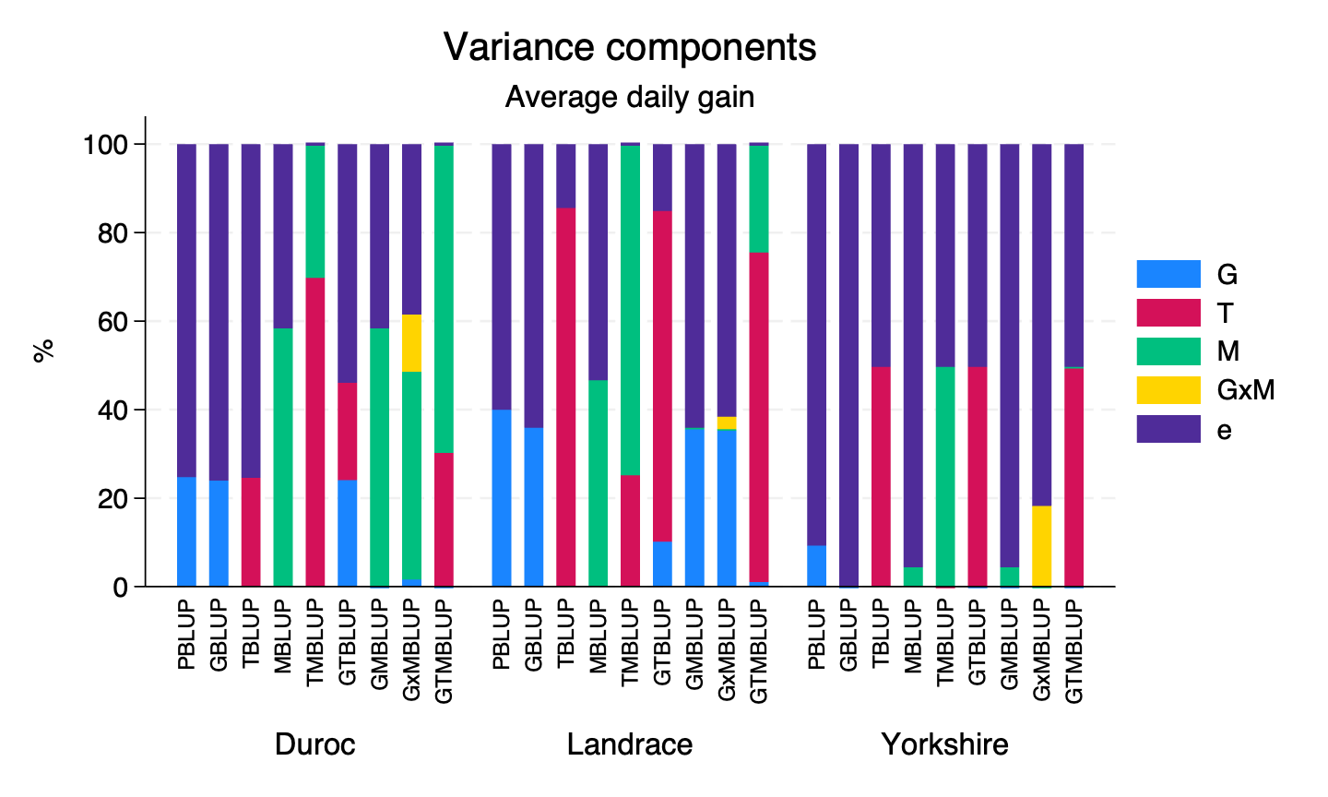
Fig. S5 Variance components expressed as proportions of the total phenotypic variance for average daily gain, based on REML estimates within breeds (Duroc, Landrace, and Yorkshire). Each bar represents a model.
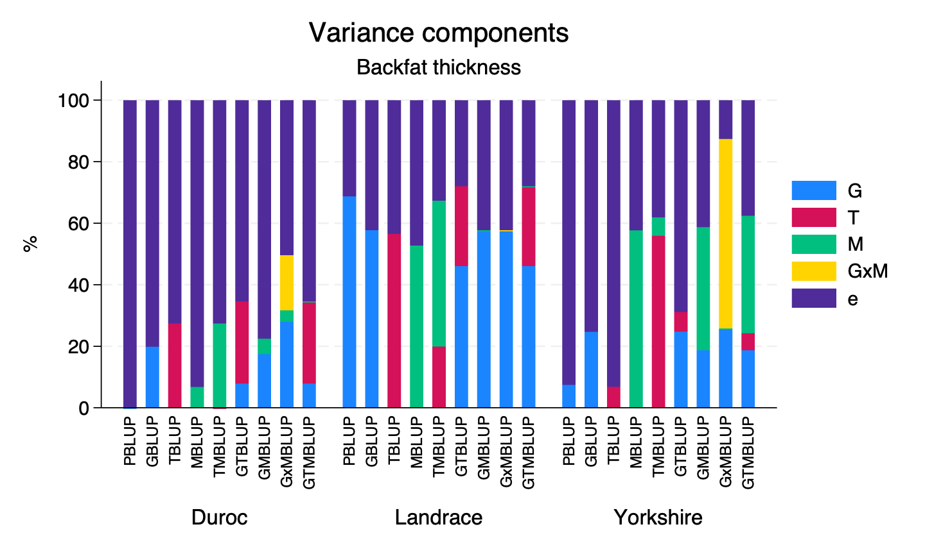
Fig. S6 Variance components expressed as proportions of the total phenotypic variance for backfat thickness, based on REML estimates within breeds.
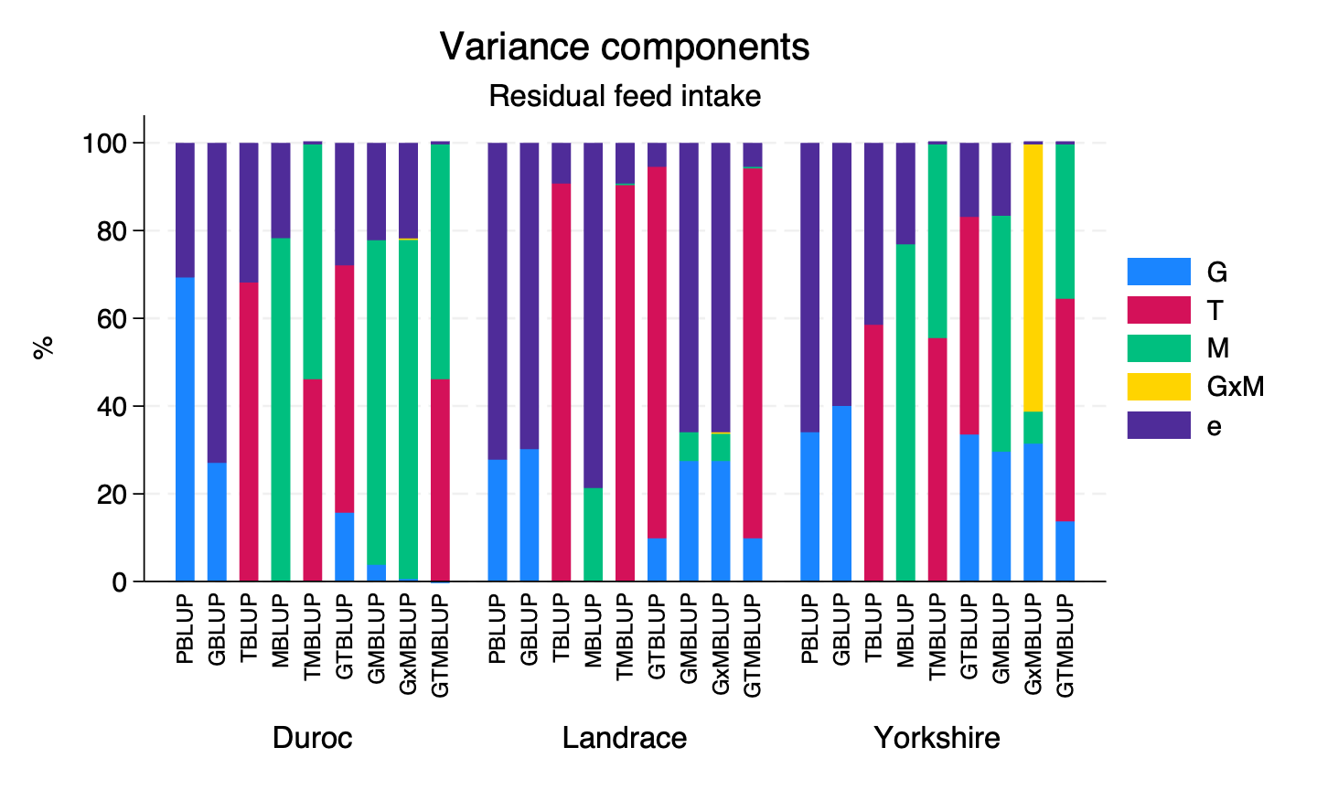
Fig. S7 Variance components expressed as proportions of the total phenotypic variance for residual feed intake, based on REML estimates within breeds.
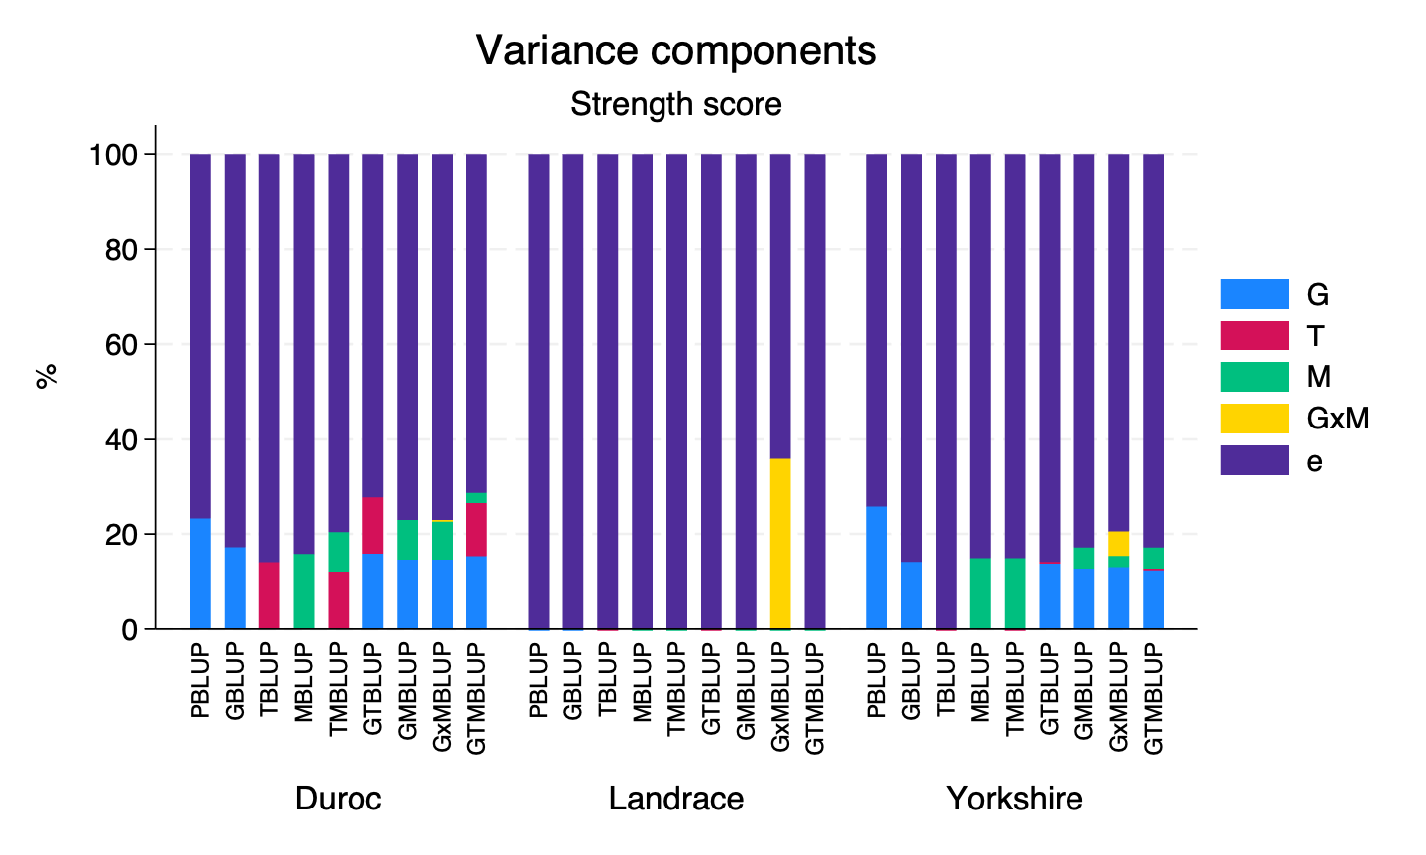
Fig. S8 Variance components expressed as proportions of the total phenotypic variance for strength score, based on REML estimates within breeds.

References
1. Henderson CR. Statistical methods in animal improvement: historical overview. In: Gianola D, Hammond K, editors. Advances in statistical methods for genetic improvement of livestock. Berlin: Springer-Verlag; 1990. p. 2–14.
2. Henderson CR. Best linear unbiased estimation and prediction under a selection model. Biometrics. 1975;31(2):423–47.
3. Goldberger AS. Best linear unbiased prediction in the generalized linear regression model. Journal of the American Statistical Association. 1962;57(298):369–75.
4. Gianola D, Rosa GJM. One hundred years of statistical developments in animal breeding. Annual Review of Animal Biosciences. 2015;3:19–56.
5. Rosa GJM. Quantitative methods applied to animal breeding. In: Spangler ML, editor. Animal breeding and genetics. New York: Springer; 2023. p. 25–49.
6. Zuidhof MJ, Schneider BL, Carney VL, Korver DR, Robinson FE. Growth, efficiency, and yield of commercial broilers from 1957, 1978, and 2005. Poultry Science. 2014;93(12):2970–82.
7. Weigel KA, VanRaden PM, Norman HD, Grosu H. A 100-Year Review: Methods and impact of genetic selection in dairy cattle—From daughter–dam comparisons to deep learning algorithms. Journal of Dairy Science. 2017;100(12):10234–50.
8. Weller JI. Genomic selection in animals. Hoboken: John Wiley & Sons; 2016. 192 p.
9. Meuwissen T, Hayes B, Goddard M. Genomic selection: A paradigm shift in animal breeding. Animal Frontiers. 2016;6(1):6–14.
10. Ritland K. A marker-based method for inferences about quantitative inheritance in natural populations. Evolution. 1996;50(3):1062–73.
11. Nejati-Javaremi A, Smith C, Gibson JP. Effect of total allelic relationship on accuracy of evaluation and response to selection. Journal of Animal Science. 1997;75(7):1738–45.
12. Legarra A, Christensen OF, Aguilar I, Misztal I. Single Step, a general approach for genomic selection. Livestock Science. 2014;166:54–65.
13. VanRaden PM. Efficient methods to compute genomic predictions. Journal of Dairy Science. 2008;91(11):4414–23.
14. Meuwissen T, Hayes B, Goddard M. Prediction of total genetic value using genome-wide dense marker maps. Genetics. 2001;157(4):1819–29.
15. Wolc A, Stricker C, Arango J, Settar P, Fulton JE, O'Sullivan NP, et al. Breeding value prediction for production traits in layer chickens using pedigree or genomic relationships in a reduced animal model. Genetics Selection Evolution. 2011;43(1):5.
16. Fang L, Teng J, Lin Q, Bai Z, Liu S, Guan D, et al. The Farm Animal Genotype–Tissue Expression (FarmGTEx) Project. Nature Genetics. 2025;57(4):786–96.
17. The Bio Revolution: Innovations transforming economies, societies, and our lives. McKinsey Global Institute; 2020.
18. Wientjes YCJ, Bijma P, Vandenplas J, Calus MPL. Multi-population genomic relationships for estimating current genetic variances within and genetic correlations between populations. Genetics. 2017;207(2):503–15.
19. Warr A, Affara N, Aken B, Beiki H, Bickhart DM, Billis K, et al. An improved pig reference genome sequence to enable pig genetics and genomics research. GigaScience. 2020;9(6).
20. Groenen MAM, Archibald AL, Uenishi H, Tuggle CK, Takeuchi Y, Rothschild MF, et al. Analyses of pig genomes provide insight into porcine demography and evolution. Nature. 2012;491(7424):393–8.
21. Luigi-Sierra MG, Gòdia M, Fredholm M, Guo X, Madsen O. Characterization of the -omics architecture for growth and subcutaneous fat deposition traits in three commercial pig breeds. 2026.
22. Gilmour AR, Thompson R, Cullis BR. Average information REML: An efficient algorithm for variance parameter estimation in linear mixed models. Biometrics. 1995;51(4):1440–50.
23. Patterson HD, Thompson R. Recovery of Inter-Block Information when Block Sizes are Unequal. Biometrika. 1971;58(3):545–54.
24. Duenk P, Bijma P. Bias in estimated variance components and breeding values due to pre-correction of systematic effect. EAAP - 74th Annual Meeting; Lyon. Wageningen: Wageningen Academic Publishers; 2023. p. 785.
25. Henderson CR. Best linear unbiased prediction of nonadditive genetic merits in noninbred populations. Journal of Animal Science. 1985;60(1):111–7.
26. Jiang Y, Reif JC. Modeling epistasis in genomic selection. Genetics. 2015;201(2):759–68.
27. Vourlaki I-T, Luigi-Sierra MG, Ayres L, Ramayo-Caldas Y, Calus MPL, Karlskov-Mortensen P, et al. Integrating multi-omics data for deep learning–based prediction of production and feed efficiency traits in pigs. Genetics Selection Evolution. 2026.
28. Clutter AC. Genetics of performance traits. In: Rothschild MF, Ruvinsky A, editors. The genetics of the pig. Wallingford: CABI; 2011. p. 325–54.
29. Li X, Kennedy BW. Genetic parameters for growth rate and backfat in Canadian Yorkshire, Landrace, Duroc, and Hampshire pigs. Journal of Animal Science. 1994;72(6):1450–4.
30. Vourlaki IT, Piles M, Jové-Juncà T, Ramayo-Caldas Y, Quintanilla R, Ballester M. Incorporating genomic and transcriptomic effects in joint linear and non-linear structural models for predicting complex traits in pigs. animal. 2026;20(3):101765.
31. Cortijo S, Wardenaar R, Colomé-Tatché M, Gilly A, Etcheverry M, Labadie K, et al. Mapping the epigenetic basis of complex traits. Science. 2014;343(6175):1145–8.
32. Hu Y, Morota G, Rosa GJM, Gianola D. Prediction of plant height in Arabidopsis thaliana using DNA methylation data. Genetics. 2015;201(2):779–93.
33. Wang P, Lehti-Shiu MD, Lotreck S, Segura Abá K, Krysan PJ, Shiu S-H. Prediction of plant complex traits via integration of multi-omics data. Nature Communications. 2024;15(1):6856.
34. Hansen PB, Ruud AK, de los Campos G, Malinowska M, Nagy I, Svane SF, et al. Integration of DNA methylation and transcriptome data improves complex trait prediction in Hordeum vulgare. Plants. 2022;11(17):2190.
35. Kühl M, Wu P-Y, Shrestha A, Engelhorn J, Mukherjee S, Hartwig T, et al. Methylome differences among barley inbreds and their association with genomic, transcriptomic, and phenotypic variation. Journal of Experimental Botany. 2026;77(2):411–30.
36. Amiri Roudbar M, Mohammadabadi MR, Ayatollahi Mehrgardi A, Abdollahi-Arpanahi R, Momen M, Morota G, et al. Integration of single nucleotide variants and whole-genome DNA methylation profiles for classification of rheumatoid arthritis cases from controls. Heredity. 2020;124(5):658–74.
37. Shah S, Bonder Marc J, Marioni Riccardo E, Zhu Z, McRae Allan F, Zhernakova A, et al. Improving phenotypic prediction by combining genetic and epigenetic associations. The American Journal of Human Genetics. 2015;97(1):75–85.
38. McCartney DL, Hillary RF, Stevenson AJ, Ritchie SJ, Walker RM, Zhang Q, et al. Epigenetic prediction of complex traits and death. Genome Biology. 2018;19(1):136.
39. Nabais MF, Gadd DA, Hannon E, Mill J, McRae AF, Wray NR. An overview of DNA methylation-derived trait score methods and applications. Genome Biology. 2023;24(1):28.
40. Thompson M, Hill BL, Rakocz N, Chiang JN, Geschwind D, Sankararaman S, et al. Methylation risk scores are associated with a collection of phenotypes within electronic health record systems. npj Genomic Medicine. 2022;7(1):50.
41. Barbu MC, Shen X, Walker RM, Howard DM, Evans KL, Whalley HC, et al. Epigenetic prediction of major depressive disorder. Molecular Psychiatry. 2021;26(9):5112–23.
42. Mollandin F, Acloque H, Ballester M, Bink M, Calus M, Crespo-Piazuelo D, et al. Guiding eQTL mapping and genomic prediction of gene expression in three pig breeds with tissue-specific epigenetic annotations from early development. Genomics. 2026;118(1):111158.
43. Xiang R, Breen E, Bolormaa S, Liu Z, Vander Jagt CJ, Dong M, et al. Integrating extensive functional annotations and multiomics of cattle enhances climate resilience prediction and mapping. Proceedings of the National Academy of Sciences. 2025;122(49):e2514736122.
44. Perez BC, Bink MCAM, Svenson KL, Churchill GA, Calus MPL. Adding gene transcripts into genomic prediction improves accuracy and reveals sampling time dependence. G3 Genes|Genomes|Genetics. 2022.
45. Jia X, Kang Z, Wang G, Zhang K, Fu X, Li C, et al. Long-read sequencing-based transcriptomic landscape in longissimus dorsi and transcriptome-wide association studies for growth traits of meat rabbits. Frontiers in Veterinary Science. 2024;Volume 11 - 2024.
46. Haas VP, Wellmann R, Duenk P, Oster M, Ponsuksili S, Bennewitz J, et al. Incorporating transcriptomic data into genomic prediction models to improve the prediction accuracy of phenotypes of efficiency traits. Genetics Selection Evolution. 2025;57(1):59.
47. Jové-Juncà T, Haas VP, Calus MPL, Ballester M, Quintanilla R. Using transcriptomic data to improve the prediction of immunity traits in pigs. animal. 2026;20(2):101742.
48. Guo Z, Magwire MM, Basten CJ, Xu Z, Wang D. Evaluation of the utility of gene expression and metabolic information for genomic prediction in maize. Theoretical and Applied Genetics. 2016;129(12):2413–27.
49. Morgante F, Huang W, Sørensen P, Maltecca C, Mackay TFC. Leveraging multiple layers of data to predict Drosophila complex traits. G3 Genes|Genomes|Genetics. 2020;10(12):4599–613.
50. Costes V, Lopez-Catalina A, Raja Ravi Shankar A, Costa Monteiro Moreira G, Martel S, Liétar L, et al. The RUMIGEN EpiChip: a versatile, medium density DNA methylation Beadchip for large scale population studies in cattle. bioRxiv. 2025:2025.12.19.695474.
51. Henderson CR. Applications of linear models in animal breeding: University of Guelph; 1984. 462 p.
52. Robinson GK. That BLUP is a good thing: the estimation of random effects. Statistical Science. 1991;6(1):15–32, 18.
53. Harville DA. BLUP (Best Linear Unbiased Prediction) and beyond. In: Gianola D, Hammond K, editors. Advances in statistical methods for genetic improvement of livestock. Berlin: Springer-Verlag; 1990. p. 239–76.
54. Mrode RM, Pocrnic I. Linear models for the prediction of the genetic merit of animals. Fourth ed. Wallingford: CABI; 2023. 412 p.
55. Stefansson OA, Sigurpalsdottir BD, Rognvaldsson S, Halldorsson GH, Juliusson K, Sveinbjornsson G, et al. The correlation between CpG methylation and gene expression is driven by sequence variants. Nature Genetics. 2024.
56. Zhou X, Im HK, Lee SH. CORE GREML for estimating covariance between random effects in linear mixed models for complex trait analyses. Nature Communications. 2020;11(1):4208.
57. Christensen OF, Börner V, Varona L, Legarra A. Genetic evaluation including intermediate omics features. Genetics. 2021;219(2).
58. Legarra A, Christensen OF. Genomic evaluation methods to include intermediate correlated features such as high-throughput or omics phenotypes. JDS Communications. 2022.
59. Guo X, Sarup P, Jahoor A, Jensen J, Christensen OF. Metabolomic-genomic prediction can improve prediction accuracy of breeding values for malting quality traits in barley. Genetics Selection Evolution. 2023;55(1):61.
60. Raffo MA, Sarup P, Jensen J, Guo X, Jensen JD, Orabi J, et al. Genomic prediction for yield and malting traits in barley using metabolomic and near-infrared spectra. Theoretical and Applied Genetics. 2025;138(1):24.
61. Guo X, Sarup P, Bay Nord A, Henryon M, Ostersen T, Christensen OF. Metabolomic-genomic prediction realizes small increases in accuracy of estimated breeding values for daily gain in pigs. Genetics Selection Evolution. 2025;57(1):24.

